**Application and Features explanation:**

This application provides the user with basic Facebook experience, like been enable to post or see friends who also using this application. The program saves as well last location and size of a window providing better user experience.

**1.** **Random friend liked pages:** From a list of friends, who are also using this application, pick randomly one friend and see 10 pages that this friend likes. The pages are shown as a grid of pictures 2 * 5.

**2. Find friends by city:** This feature helps the user to see in his list of a friends, who are also using this application, only the friends in a specific location (provided by the user).

**Use case diagram:**

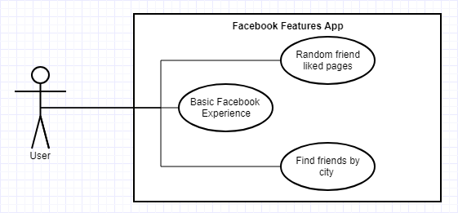

**Sequence diagram:**

*RandomFriendLikedPages*

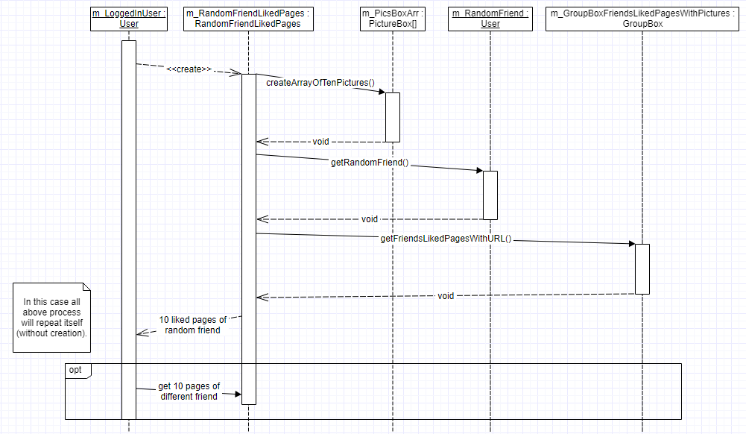

*FriendsByRequest*

**Class diagram:**

